A University Attachment Letter
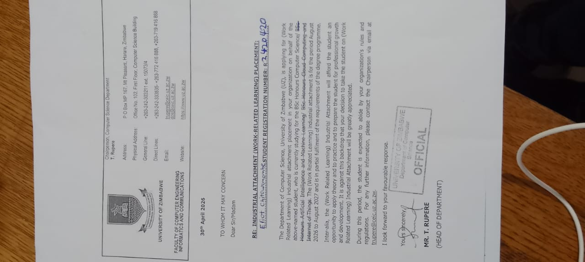
798 Helvetia Drive, Helensvale, Borrowdale
Harare
02 May 2026

Dear Sir/Madam
RE: Application for Industrial Attachment (Computer Science)
I am writing to apply for an Industrial Attachment opportunity at your organisation. I am currently pursuing a Bachelor of Science Honours Degree in Computer Science at the University of Zimbabwe, and I am eager to gain practical, hands-on experience in a professional IT environment.

Through my academic studies and personal projects, I have developed a strong foundation in IT support, networking, and software development. I have experience in installing, configuring, and troubleshooting computer systems, as well as providing technical support to users. Additionally, I possess basic knowledge of system maintenance, network security, and performance monitoring.

I am seeking an opportunity that will allow me to apply my technical skills while gaining valuable industry experience. I am a motivated and quick learner with strong problem-solving abilities, and I am confident that I can contribute positively to your organisation while continuing to develop professionally.

Please find my CV attached for your consideration. I would greatly appreciate the opportunity to further discuss how I can add value to your organisation.

Thank you for your time and consideration.

Email: chitowamombeeliot00@gmail.com
Contact: 0779933702

Curriculum Vitae
For
Eliot Chitowamombe
Address: 798 Helvetia Drive, Helensvale, Borrowdale
Email:chitowamombeeliot00@gmail.com
Portfolio: https://eliot3886.github.io/portifolio/
Cell: 0779933702

Personal Details
ID Number 42-2006916T-42
Date Of Birth 28 June 2004
Marital Status Single
Sex Male
Languages Shona & English
Nationality Zimbabwean
Religion Christian
Attachment Objectives

- Highly driven and technically proficient Computer Science student at the University of Zimbabwe with a solid foundation in Software Engineering, Artificial Intelligence, Mobile App Development, IT Support, and Networking.
- . Proven track-record in building full-stack applications using React, Django, and Kotlin.
- Seeking a 1-year Industrial Attachment to apply advanced technical skills in software innovation and system maintenance to improve organizational efficiency and drive digital solutions.
Personal Attributes
- Good interpersonal and communication
- Strong work ethic
- Creative & Fast learning
- Team player
- Can handle pressure both under supervision and otherwise
- Adaptability and proactive mindset

Languages
- English(Fluent)
- Shona(Native)
- Ndebele(Average)
- Portuguese (Professional Working Proficiency)

Academic Qualifications
Tertiary level University of Zimbabwe
Programme: Bachelor of Science Honours Degree in Computer Science

A level Certificate
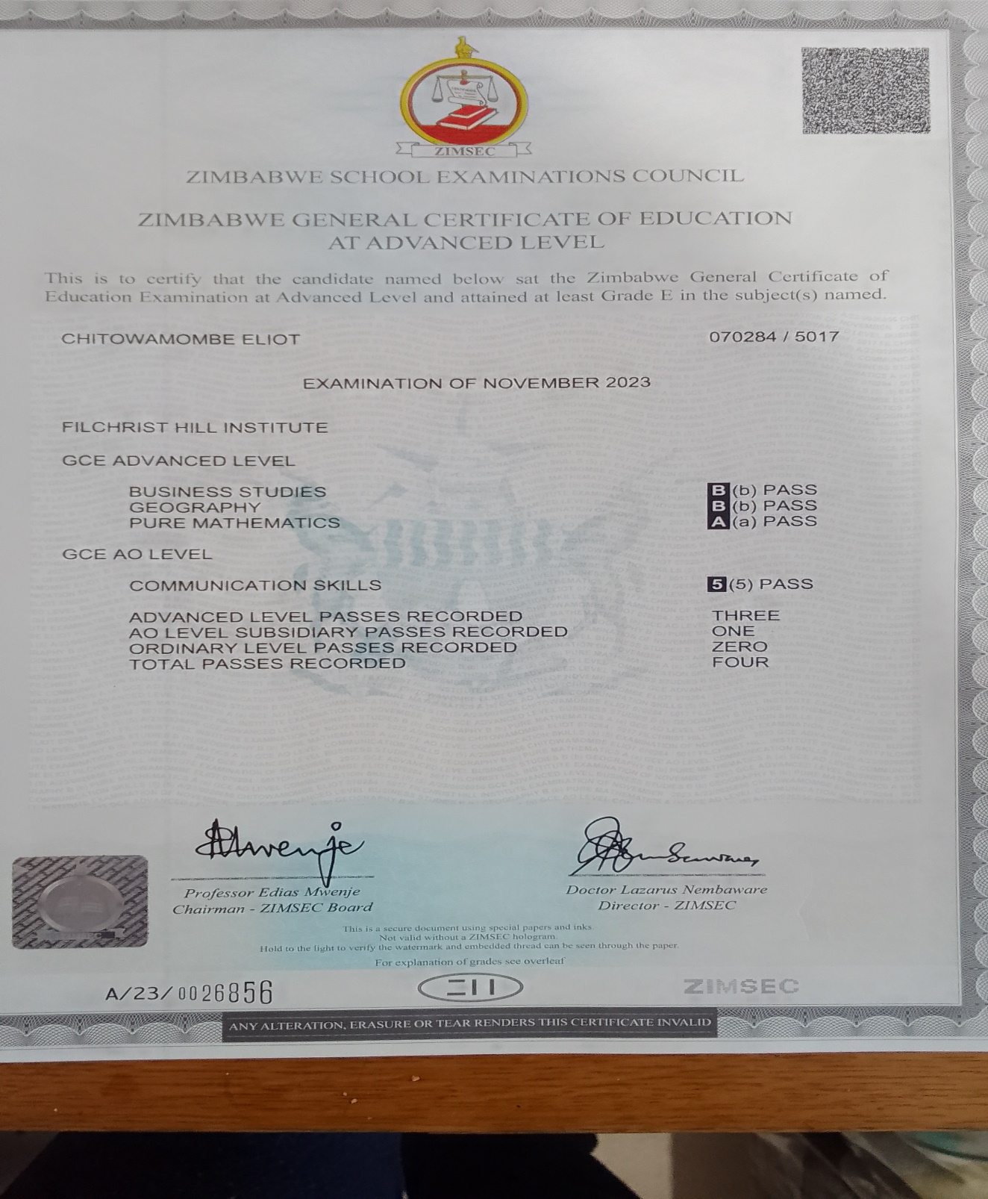

O level Certificates
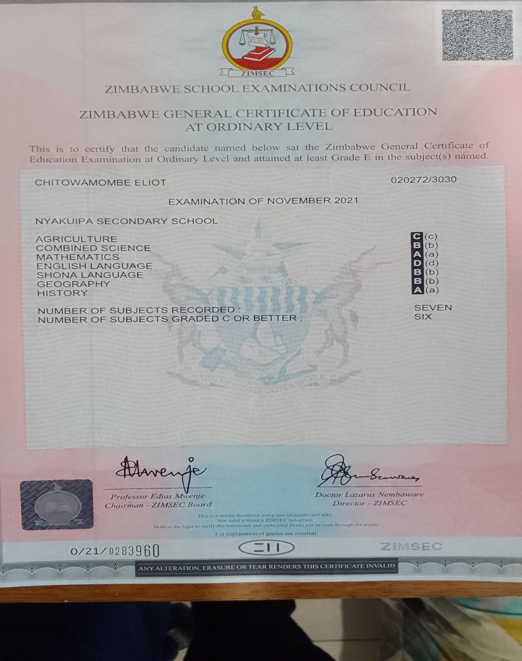

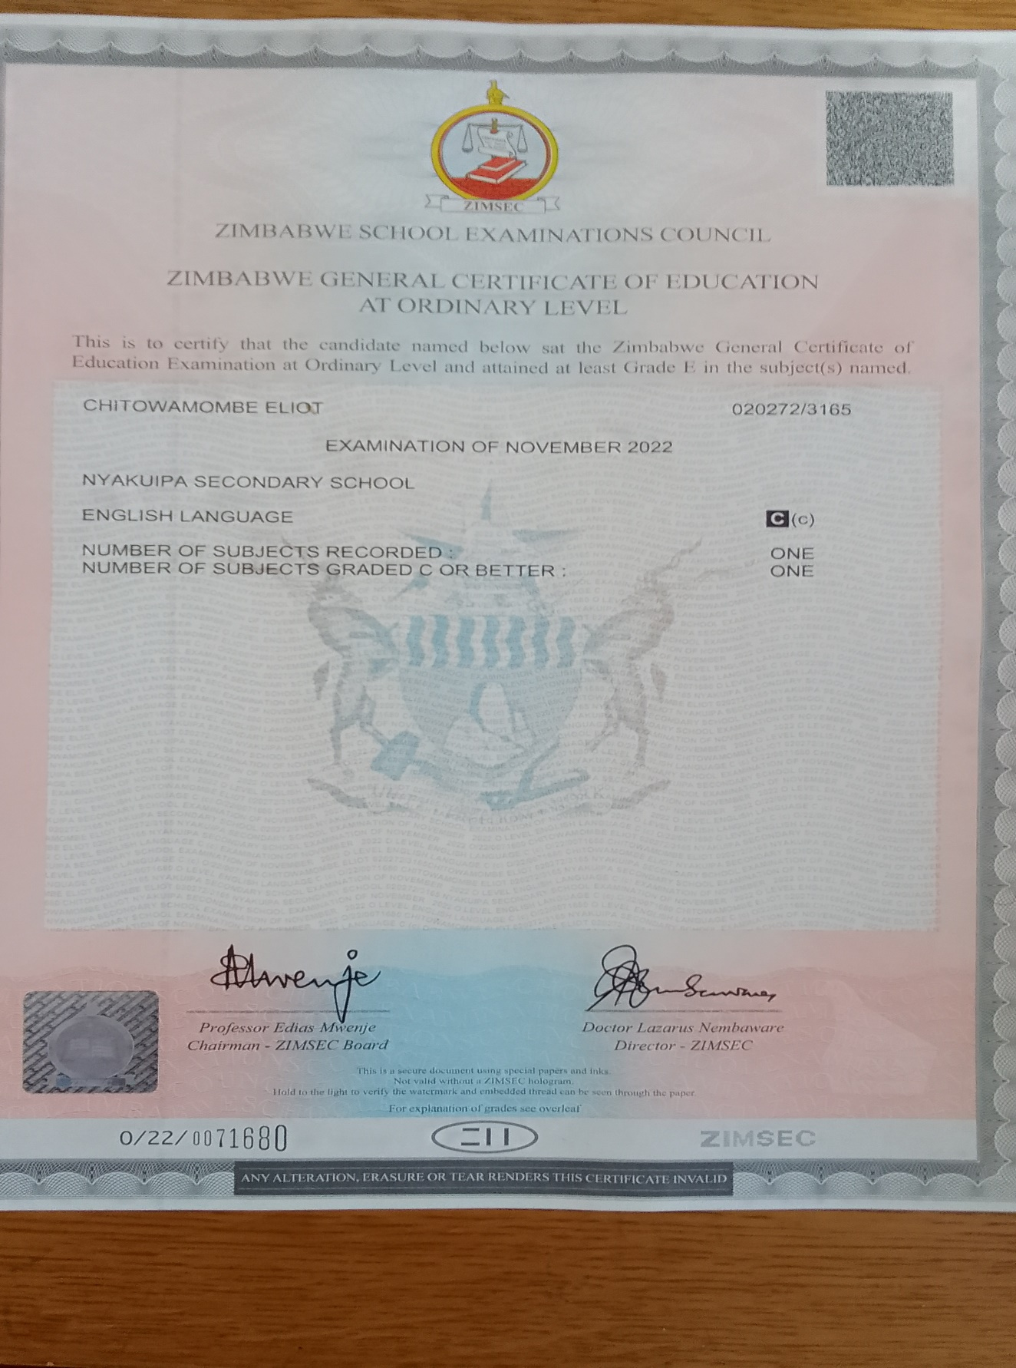
Technical Skills

- Software Development: React.js, Django REST Framework, JavaScript, HTML5, CSS3, Kotlin (Android SDK).
- Programming & Data: Python, Java, SQL (Relational Database Management), Data Structures & Algorithms.
- IT Support & Networking: Hardware diagnostics, troubleshooting, network configuration, and system maintenance.
- Version Control & Tools: Git, GitHub, VS Code, Android Studio, Linux Environment.

Certifications

- CS50: Intro to AI with Python — Harvard University 2025
- Android Mobile App Development — The BOOST Fellowship 2026
- Graphic Designing — Laton Impression Academy 2025
- ICDL Profile Certificate — ICDL Africa 2024

Technical Projects

- Farmer2Market Android Mobile Application | Django, React, Kotlin
Built a secure marketplace with JWT authentication, farmer IDs, and a mobile commerce application.

- Dube Upholstery Web App | React.js
Deployed a modern, responsive web application for business operations. Live at https://dubeupholstery.store

Official Academic Transcript
Part 2.2 (Current)
HCS212 Machine Learning (2.1)
RCE301 Research and Innovation Skills (3)
HCS211 Data Communications and Computer Network (Waiting for results)
SDLSCE201 Student Development and Skills (Waiting for results)
HCS213 Operating Systems and Computer Architecture (Waiting for the exam)
LAICCEIND200 Language Acquisition and Intercultural Communication For Faculty of Computer Engineering And Informatics - Ndebele(Waiting for the exam)

Part 2.1
HCS202 Software Engineering (2.2)
HCS204 Discrete Mathematics (2.1)
CCLSCE201 Critical Consciousness and Life Skills 1( Distinction)
HCS201 Object Oriented Programming (2.2)
HCS203 Artificial Intelligence and Expert Systems (3)
Part 1.2
HCS112 Electrical and Electronic Principles 1 (Distinction)
HCS114 Database Design and Development (2.2)
LAICCEIPO Language: Portuguese (Faculty of Computer Eng) 1 (Distinction)
HCS113 Web and Mobile Computing (3)
HCS111 Data Structures and Algorithms (2.2)
Part 1.1
HCS101 Programming Fundamentals (2.1)
HCS102 Statistics for Computer Science 1 (Distinction)
HCS103 Calculus 2.1 Sem 1 / 2024 HCS104 Linear Algebra (2.2)
IDCE101 Information and Digital Skills (2.1)

